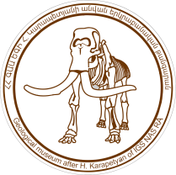
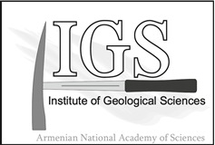
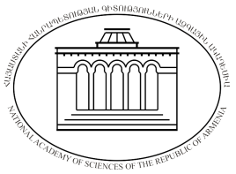

NATIONAL ACADEMY OF SCIENCES OF REPUBLIC OF ARMENIA
INSTITUTE OF GEOLOGICAL SCIENCES

INTERNATIONAL CONFERENCE
MUSEUMS OF NATURAL SCIENCES AS A FACTOR OF DEVELOPMENT OF GEOTOURISM

80th ANNIVERSARY OF THE GEOLOGICAL MUSEUM NAMED AFTER HOVHANNES KARAPETYAN, 1938-2018

YEREVAN, ARMENIA, 23-26 OCTOBER, 2018

FIRST CIRCULAR

Yerevan – 2018

The museum was founded in 1938 based on the exhibition of rich and diverse collections of prominent geologist, Professor Hovhannes Karapetyan, adjunct to the Institute of Geological Sciences of the Armenian branch of the Academy of Sciences of the USSR.
The exhibition was related to the desire of a group of participants of the 17th International Geological Congress in Moscow to get acquainted with Armenia's geology.
In this first Circular, we announce the conference and provide information about conference themes. We ask you to complete the “Expression of Interest” form that is provided as a separate attachment. Please return this form preferably by March 30, 2018, to armmuseum80@geology.am.

CONFERENCE PURPOSE

Combine the potential of Museums of Natural Sciences for sustainable development of Museums, strengthening eco-education, geotourism development in the Republic of Armenia.

CONFERENCE THEMES

- HISTORY OF GEOLOGY IN ARMENIA
Subtheme
- Activities and biographies of famous naturalists.
- The history of Museums of Natural Sciences.
- Best practices and thematic researches in Natural History Museums.

- NATURAL HISTORY MUSEUMS AND CONTEMPORARY ISSUES
Subtheme
- Scientific tourism policy and strategy and Natural History Museums. How Natural History Museums are promote economic development and investment, acting as tourist destination?
- Natural History Museums and their tourist services.
- Collaboration and development perspectives between Natural History Museums, specially protected areas, tour operators and travel agencies.
- Natural History Museums as eco-education centers.
- Eco-museum as a model of environmental Museum and the nature protection problem within its framework.

- GEOSCIENCE FOR SOCIETY
Subtheme
- Protection and use of unique geological monuments.
- Geological studies and science Festivals based on them.
- Geotourism, ecotourism.

LOCAL ORGANIZING COMMITTEE

- Dr. Khachatur Meliksetian (Institute of Geological Sciences)
- Dr. Sci. Georgi Khomizuri (Institute of Geological Sciences)
- Dr. Lilit Sahakyan (Institute of Geological Sciences)
- Mrs. Gayane Grigoryan (Institute of Geological Sciences)
- Mrs. Marine Haroyan (ICOM National Center of Museums of Armenia NGO)
- Mr. Khachik Hakobyan (Ministry of Nature Protection of the Republic of Armenia)

CONFERENCE SCHEDULE

23 October, 2018 - Arrival to Yerevan

24 October – Conference

25 October- Excursions with Museums and unique geological monuments of Armenia

25 October - Conference dinner

26 October, 2018 - Departure from Yerevan

Post-conference excursions

26, 27 October – Post - conference excursions with unique geological monuments of Armenia

- More detailed information will be available in 2nd Circular

- For any questions please contact organising committee by e-mail: armmuseum80@geology.am

- Follow Web site of Institute of Geological Sciences of NAS RA for updates: http://geology.am

