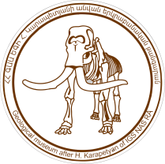
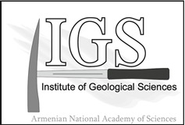
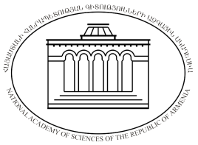

NATIONAL ACADEMY OF SCIENCES OF REPUBLIC OF ARMENIA INSTITUTE OF GEOLOGICAL SCIENCES

INTERNATIONAL CONFERENCE MUSEUMS OF NATURAL SCIENCES AS A FACTOR OF DEVELOPMENT OF GEOTOURISM

80th ANNIVERSARY OF THE GEOLOGICAL MUSEUM NAMED AFTER HOVHANNES KARAPETYAN, 1938-2018

YEREVAN, ARMENIA, 23-26 OCTOBER, 2018
Expression of interest

First Name:
Second Name:
Country:
E-mail:
Telephone:
Comments:

(In Comments section please mention your preliminary interest to (I) participate in the conference, (II) to make a presentation, (III) to participate in conference excursions and (IV) intention to attend the meeting together with an accompanying person)

- Please return this form not later than March 30th, 2018, to armmuseum80@geology.am

